TWHA Order Form
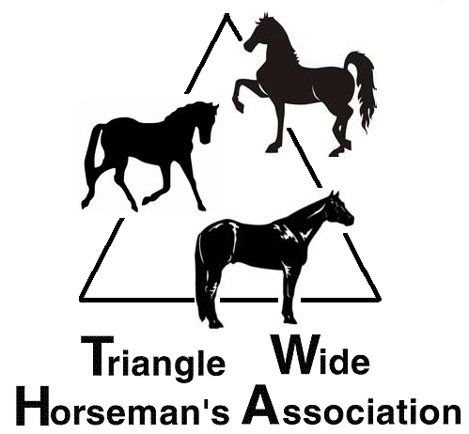
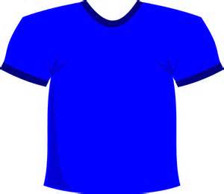
All orders must be received by July 15th, 2014

Name:
Address
City, State Zip
Email
Item | Colors | Size Youth  (Circle One) | Size Adult  (Circle One) | Price  Each | Total
Short Sleeve T-Shirt | Colors:Hot Pink | ____Sm ____Med ____Lg ____XLG | ____Sm ____Med ____Lg ____XLG | $12.00
Short Sleeve T-Shirt | Colors: Grey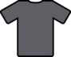 | ____Sm ____Med ____Lg ____XLG | ____Sm ____Med ____Lg ____XLG | $12.00
Short Sleeve T-Shirt | Colors: Navy 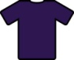 | ____Sm ____Med ____Lg ____XLG | ____Sm ____Med ____Lg ____XLG | $12.00
Long Sleeve T-Shirt | Colors: Hot Pink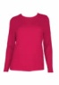 | ____Sm ____Med ____Lg ____XLG | ____Sm ____Med ____Lg ____XLG | $15.00
Long Sleeve T-Shirt | Colors: Grey 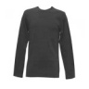 | ____Sm ____Med ____Lg ____XLG | ____Sm ____Med ____Lg ____XLG | $15.00
Long Sleeve T-Shirt | Colors: Navy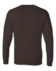 | ____Sm ____Med ____Lg ____XLG | ____Sm ____Med ____Lg ____XLG | $15.00
Hooded Sweat shirts | Colors: Hot Pink 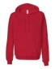 | ____Sm ____Med ____Lg ____XLG | ____Sm ____Med ____Lg ____XLG | $20.00
Hooded Sweat shirts | Colors: Grey 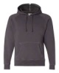 | ____Sm ____Med ____Lg ____XLG | ____Sm ____Med ____Lg ____XLG | $20.00
Hooded Sweat shirts | Colors: Navy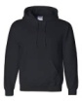 | ____Sm ____Med ____Lg ____XLG | ____Sm ____Med ____Lg ____XLG | $20.00
Men’s Ball Caps |  | Color: Brown Black |  | $12.00
Ladies Ball Caps |  | Color: Brown Black Hot Pink |  | $12.00
 |  | Total Amount Due
Make check payable to: TWHA |  | Return Order Form to:  TWHA c/o Kim Moser  155 Grayson Jenkins Road, Apex, NC 27523
Payment received: |  | Cash Check Check number _____________

